a) Different ways to build a Java Web Application

1.Servlet/JSP

Does lets work for the programmer

Servelet -> Store the Java code that does the server-side processing

JavaServer Pages (JSP) -> Store the HTML that defines the user interface

2.JSF

JavaServer Faces (JSF) -> Designed to replace servlets and JSPs.

Provides a higher level API that does more work for the programmer

3. Sprint Framework

Higher level API that does more work for the programmer than the servlet/JSP API

Manages control over HTML/CSS/JS, but also, gives some control to the user  
b) Description of the architecture of a Java Web application using layers.

Presentation layer / User interface layer :

Consists of HTML pages and JSPs. A web designer works on HTML stored in these pages to create the look and feel of the user interface.

Business rules layer:

User servlets to control the flow of the application.

May call other Java classes to store and retrieve data from the database

Data access layer: Data access classes

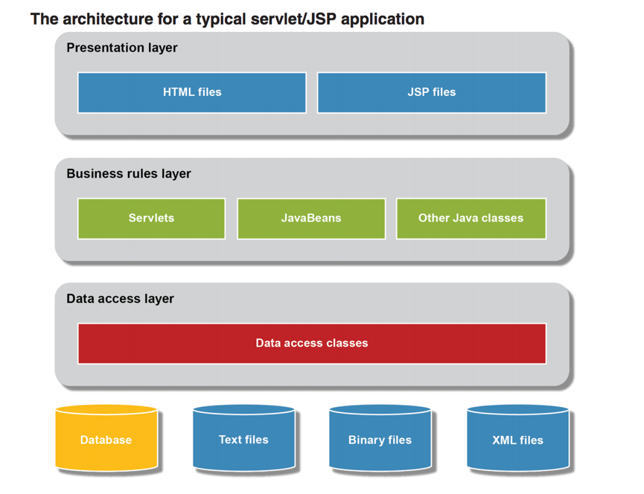

d) What is a Servlet/JSP engine? What is the difference with a Java application server? Give two examples of each one.

Servlet/JSP Engine 🡪 It is needed for a servlet/JSP application.Process the HTTP request and return an HTTP response, which is typically an HTML page.

Java web application -> It’s a hierarchy of directories and files in a standard layout  
d) The structure of a Java Web Application -A summary of the directories of a Java Web Application.

(root) 🡪 Contain HTML and JSP files for the application

WEBINF 🡪 Contains file name web.xml

WEBINF/classes 🡪 Contain servlets and other Java classes for the application

WEBINF/lib 🡪 Contains any JAR files that contain Java class libraries

META-INF 🡪 Contains the content.xml file.

e) Description of a Java Web application using the MVC model

MVC pattern

1.Model: Defines the business layer of the application.

This type of class defines the data for the business objects and provides the methods that do the business processing.

2.View: Defines the presentation layer of the application

Uses HTML documents or JSPs to present the view to the browser

3. Controller: Manages the flow of the application, this work is done by one or more servlets  
f) Description of the following concepts: Java Server Pages and Servlets. Include an example.

Java Server Pages: Helps software developers create dynamically generate web pages based on HTML, XML or other document types.

Servlets: Java program that extends the capabilities of the server. Can respond to any types of requests.